DELPHI app: technical specifications

Objective:
To develop the DELPHI (DEsign and simuLate PHase I) simulation platform and DELPHI online app for the design and conduct phase 1 trials with rule-based and adaptive designs.

Overview:
DELPHI consists of two phases: DESIGN, and TRIAL CONDUCT. In the DESIGN phase, a user can evaluate and compare the operating characteristics for potential phase 1 designs through trial simulations, and select the optimal design for the disease/biology/patient needs of the trial. After implementing a particular adaptive design, in the TRIAL CONDUCT phase, the user can implement the adaptive trial by calculating the recommended dose for the next patient. DELPHI will feature modular programming with standardized input and output parameters across designs, so that new designs can be rapidly added to the modular framework by our lab or external investigators.
For the pilot DELPHI online app, we will focus on implementing two designs using R Shiny: (1) TARGET-CRM; and (3) 3+3. The framework needs to be scalable to include additional designs.

Methods

TARGET-CRM specifications
The TARGET-CRM modifies the dfcrm package to conduct the trial simulations. The function call is presented below.
target.crm <- function(prior, target.tox, number.trials, true.tox, arrival.rate, prop.B, target.crm, min.cohortB=0, cycle.length, cohort.size, max.N, start.level)

3+3 specifications
The function call for the 3+3 design is presented below.
three.plus.three <- function(target.tox, number.trials, true.tox, arrival.rate, prop.B, cycle.length, start.level)
The detailed description of the input parameters is presented in Table 1. A detailed description of the function output is presented in Table 2. Some input parameters and output parameters only pertain to the TARGET-CRM design.
Table 1: Input parameters for TARGET-CRM and 3+3 functions
Parameter | Description | Example
GENERAL INPUT PARAMETERS
target.tox | Target toxicity probability of study agent | Probabilities range from 0 to 1.  target.tox=0.2
number.trials | Number of mock trials to simulate | Number of trials >= 1  number.trials=1000
true.tox | Vector of true toxicity probabilities for each dose level evaluated in the trial | Toxicity probabilities must increase monotonically with each subsequent dose level. Probabilities range from 0 to 1.  Example of a trial with 4 dose levels:  true.tox=c(0.05,0.12,0.20,0.30)  Here, the TRUE MTD is dose level 3 because its true toxicity probability is closest to the target toxicity probability (target.tox) of 20%.
start.level | Starting dose level | Starting dose level must be an integer ranging from 1 to total number of doses evaluated.  Example of a trial starting on dose level 2:  start.level=2
arrival.rate | Mean inter-arrival time for enrolling patients (in days) | Arrival rate is greater than 0  arrival.rate=15
prop.B | Proportion of enrolling patients belonging to Cohort B. We wish to enrich for these Cohort B patients with specific tumor subtypes / genomic alterations. | Proportion ranges from 0 to 1.  prop.B=0.1
cycle.length | Duration of DLT observation period in days | DLT observation period is greater or equal to 1.  cycle.length=28
TARGET-CRM SPECIFIC INPUT PARAMETERS
prior | Vector of prior toxicity probabilities for each dose level evaluated in the trial. | Toxicity probabilities must increase monotonically with each subsequent dose level. Probabilities range from 0 to 1.  Example of a trial with 4 dose levels:  prior=c(0.05,0.1,0.2,0.3)
target.crm  [TARGET-CRM design ONLY] | Option for different variations of the TARGET-CRM design: | target.crm=0: NO enrollment of patients at one dose below  target.crm=1: Enrollment of patients at one dose below  target.crm=2: Enrollment of patients at current best dose based on available information, cannot be higher than current dose
min.cohortB  [TARGET-CRM design ONLY] | Option to require a minimum number of Cohort B patients to be enrolled in the trial | Minimum number of Cohort B patients ranges from 0 to the maximum sample size (max.N)  min.cohortB=2
cohort.size  [TARGET-CRM design ONLY] | Number of patients to be treated at the current dose before a dose escalation decision is made. | Cohort size must be an integer greater or equal to 1.  cohort.size=3
max.N  [TARGET-CRM design ONLY] | Maximum number of patients to be enrolled | Maximum sample size must be an integer greater or equal to 1  max.N=20

Table 2: TARGET-CRM and 3+3 function outputs
Output | Description | Example
MTD.selection | Vector with the proportion of simulated trials that selected each dose level as the maximum tolerated dose (MTD) | Proportion ranges from 0 to 1. The sum of proportions across all doses must sum to 1.  Example for a trial with 4 dose levels:  1 2 3 4  0.0445 0.2735 0.3880 0.2940
PCS | Proportion of simulated trials that selected the TRUE maximum tolerated dose. The true MTD is the dose level with the true toxicity probability (true.tox) closest to the target toxicity probability (target.tox). | Proportion ranges from 0 to 1.  Example for a trial with 4 dose levels where dose level 3 is the TRUE MTD:  0.3880
patient.allocation | Vector with the proportion of patients treated at each dose level | Proportion ranges from 0 to 1. The sum of proportions across all doses must sum to 1.  Example for a trial with 4 dose levels:  0.1528 0.3448 0.2993 0.2029
obs.tox.overall | Overall proportion of patients experiencing a DLT | Proportion ranges from 0 to 1.  Example: 0.137
obs.tox.table | Vector with the proportion of patients experiencing a DLT at each dose level | Proportion ranges from 0 to 1. The sum of proportions across all doses must sum to 1.  Example for a trial with 4 dose levels:  0.0470 0.1196 0.1974 0.3006
mean.obs.N | Mean total sample size in simulated trials | Mean number ranges from 0 to max.N.
min.obs.N | Minimum total sample size in simulated trials | Minimum number ranges from 0 to max.N.
max.obs.N | Maximum total sample size in simulated trials | Maximum number ranges from 0 to max.N.
mean.cohortB | Mean number of cohort B patients treated at one dose below the current dose level (as per the TARGET-CRM design).  For the 3+3 design, mean.cohortB = 0 by default because no patient can enroll at one dose below the current dose. | Mean number ranges from 0 to max.N.  Example:  0.4965
sd.cohortB | Standard deviation (SD) of number of cohort B patients treated at one dose below the current dose level (as per the TARGET-CRM design)  For the 3+3 design, sd.cohortB = 0 by default because no patient can enroll at one dose below the current dose. | Standard deviation is greater than 0.  Example:  0.6922
mean.duration | Mean study duration in days | Mean study duration is greater than 0.  Example:  355.1
sd.duration | Standard deviation of study duration in days | Standard deviation is greater than 0.  Example:  22.9

Proposed R Shiny Interface
The proposed R Shiny interface will include 4 main “tabs”: (1) HOME; (2) DESIGN; (3) CONDUCT; and (4) HELP.
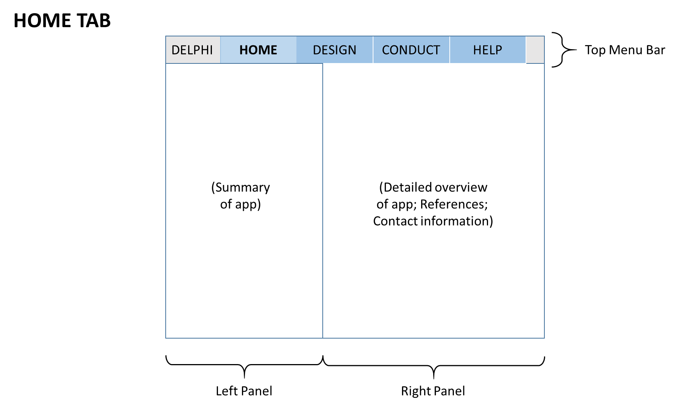
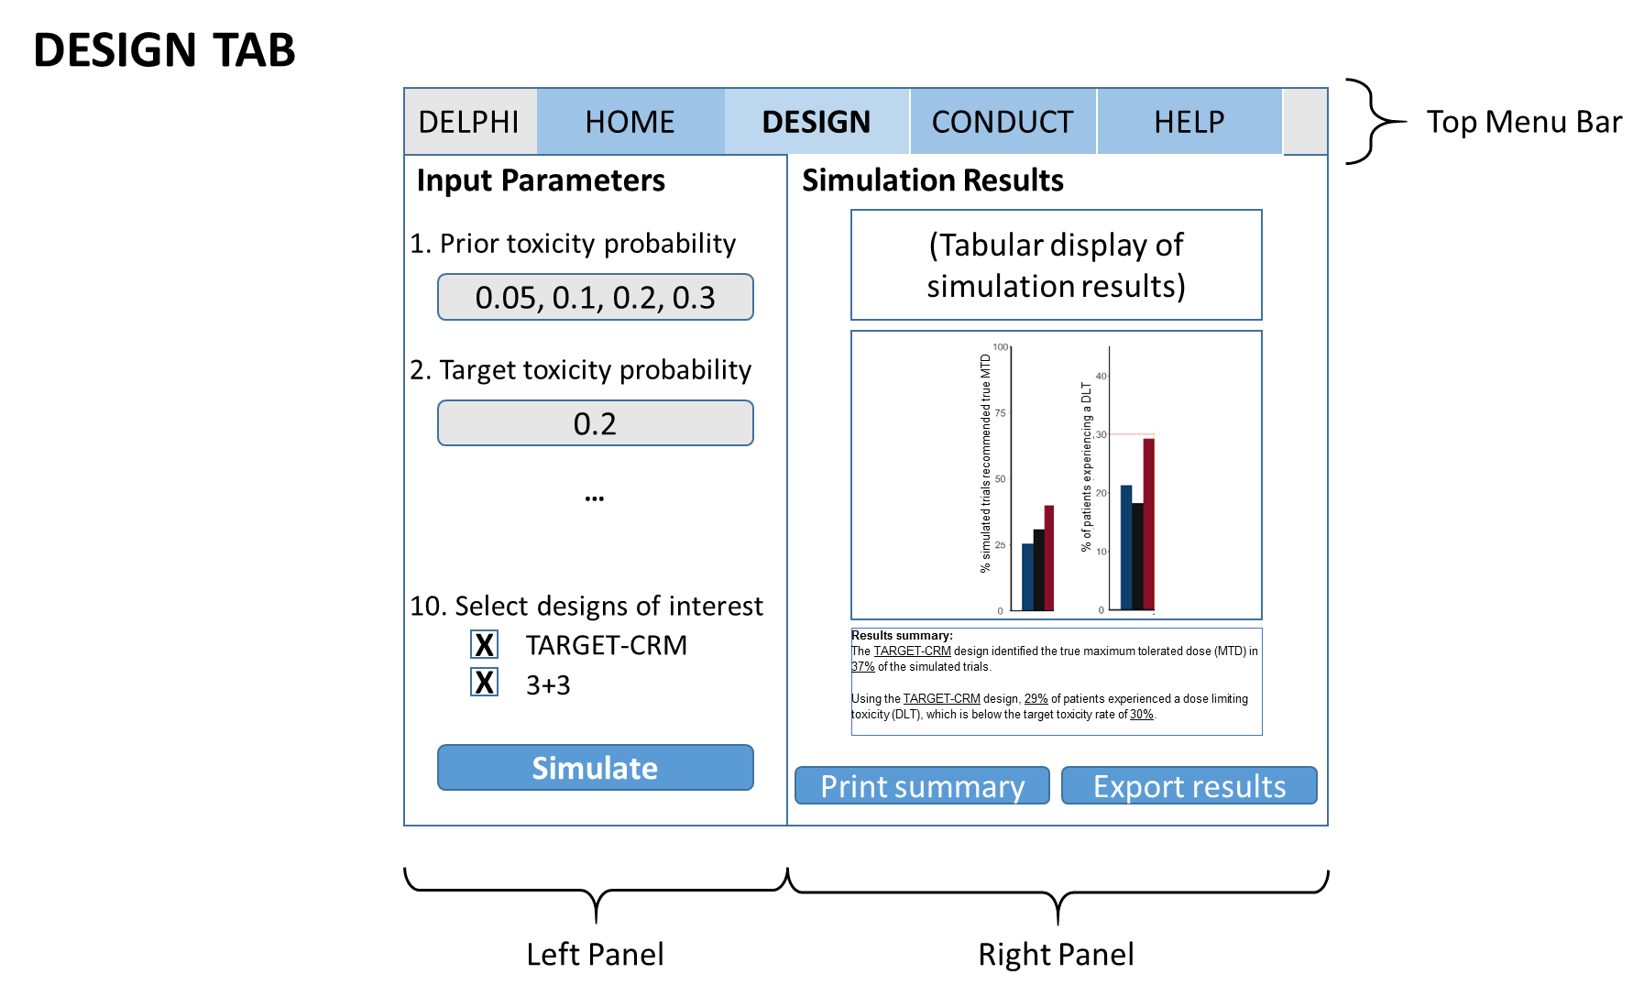
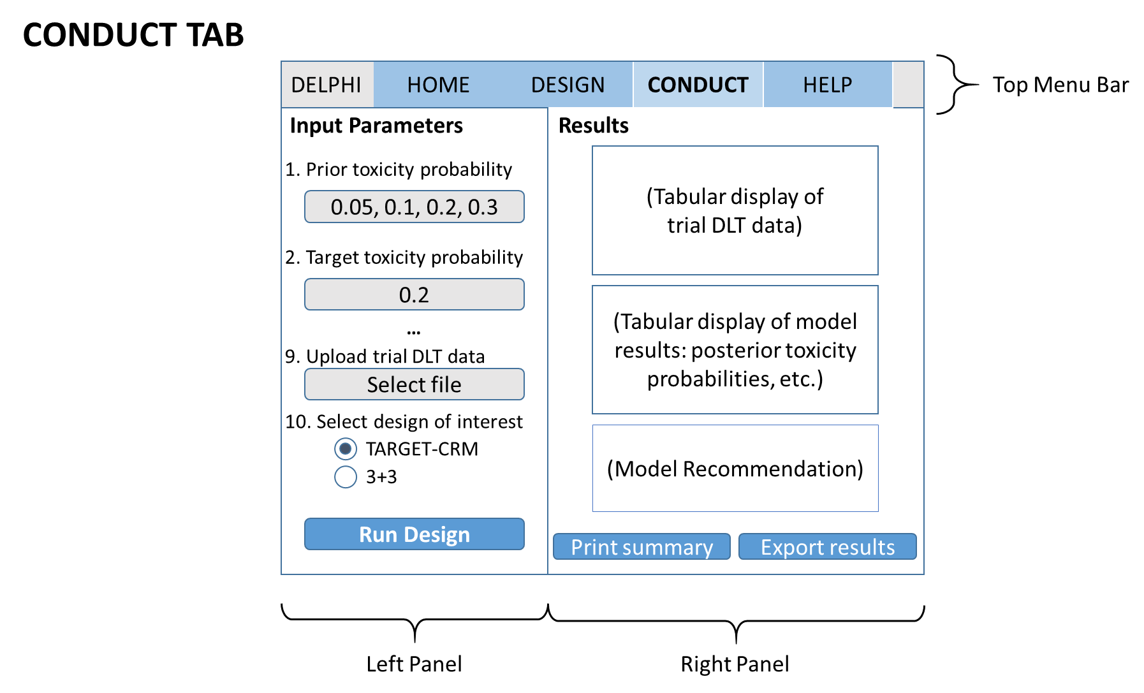

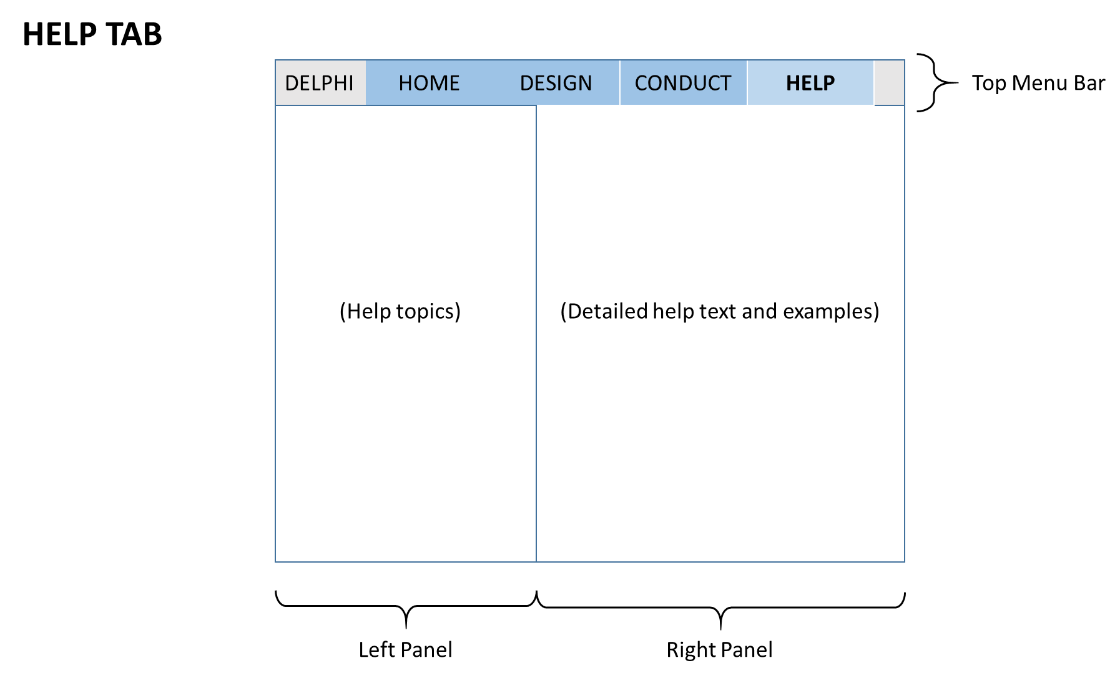

DESIGN Tab: Detailed Specifications

Table 3 presents a detailed description of the input parameters for the DESIGN tab.

Table 3: Description of input parameters for DESIGN tab
Input Parameter | Label | Tooltip | Interface | Default Value | Range
General simulation parameters
design | - Dose-escalation designs | Please select the dose escalation design(s) of interest. | Checkbox | 3+3: checked  TARGET-CRM: unchecked | Options:  - 3+3  - TARGET-CRM
dose.labels | - Dose level labels | Please enter the dose level labels for each dose level evaluated in the trial. | Text box | “-1”, “1”, “2”, “3” | Each label is an alphanumeric string
true.tox | - True toxicity probability vector | Please enter the true toxicity probabilities for each dose level evaluated in the trial. Toxicity probabilities must increase with each subsequent dose level. | Text box | 0.05,0.12,0.20,0.30 | Each numeric value ranges from 0 to 1
start.level | - Starting dose level | Please enter the starting dose level using the dose level labels above | Text box | “1” | An alphanumeric string matching one of the labels from dose.labels
target.tox | - Target toxicity probability | Please enter the target toxicity probability of the study agent. | Slider | 0.2 | 0 to 1; hundredths only
arrival.rate | - Patient enrollment rate | Please enter the average time between enrolling patients (in days). | Slider | 15 | 0 to 180; whole numbers only
cycle.length | - Duration of DLT observation period | Please enter the duration of the DLT observation period (in days). | Slider | 28 | 0 to 365; whole numbers only
prop.B | - Proportion of patients from Cohort B | Please enter the proportion of enrolled patients belonging to the “enrichment” Cohort B. | Slider | 0.1 | 0 to 1; hundredths only
number.trials | - Number of simulated trials | Please enter the number of simulated trials. A larger number of simulations increases the precision of simulation results and computation time. | Text box | 100 | 1 to 10,000; whole numbers only
TARGET-CRM simulation parameters (ONLY)
prior | - Prior toxicity probability vector | Please enter the prior toxicity probabilities for each dose level evaluated in the trial. Toxicity probabilities must increase with each subsequent dose level. | Text box | c(0.05,0.12,0.20,0.30) | Each numeric value ranges from 0 to 1
cohort.size | - Cohort size | Please enter the cohort size. The cohort size is the number of patients to be treated at the current dose level before a dose escalation decision is made. | Text box | 3 | Options:  1, 2, 3, 4, 5, 6, 7, 8, 9
max.N | - Maximum sample size | Please enter the maximum number of patients to be enrolled per trial. | Slider | 18 | 1 to 200; whole numbers only
target.crm | - TARGET-CRM option | Please enter the desired variation of the TARGET-CRM design | Drop-down menu | 1 | Option 0: NO enrollment of Cohort B patients at one dose below  Option 1: Enrollment of Cohort B patients at one dose below  Option 2: Enrollment of Cohort B patients at current dose
min.cohortB | - (Optional) Minimum enrollment of Cohort B patients | Please enter the minimum number of Cohort B patients to be enrolled in the trial. | Slider | 0 | 0 to maximum sample size (max.N)

Output figures and tables
For Figure 1, plot a histogram the proportion of simulated trials selecting each dose level as the true MTD for each design.
- Y-variable: MTD.selection.table / number.trials
- X-variable: dose level
Figure 1: Proportion of simulated trials selecting each dose level as the true MTD

For Figure 2, plot a histogram the proportion of patients experiencing a DLT per dose level for each design.
- Y-variable: obs.tox.table
- X-variable: dose level
- Horizontal dashed line at height = target.tox
- Y-axis dynamically scaled to show all bars and the horizontal dashed line.
Figure 2: Proportion of patients experiencing a DLT per dose level

For Figure 3, plot a histogram the proportion of patients allocated to each dose level for each design.
- Y-variable: patient.allocation.table
- X-variable: dose level
Figure 3: Proportion of patients allocated to each dose level
For Figure 4, plot a histogram with the mean study duration in days for each design (+/- 1 SD).
- Y-variable: mean.duration
- Error bars:
  - Lower limit = mean.duration – sd.duration
  - Upper limit = mean.duration + sd.duration
Figure 4: Mean study duration in days (+/- 1 SD)

For Table 1, output the simulation results in tabular format by dose escalation design.
Table 1: Summary of simulation results
Operating characteristic | 3+3 design | TARGET-CRM design | Output variable name  (do not display)
Proportion of Correct Selection (PCS) | 0.318 | 0.5 | PCS
True MTD | Dose 4 | Dose 4 | true.MTD
Proportion of trials selecting dose X as true MTD: |  |  | MTD.selection.table / number.trials
Dose 1 | 0.12 | 0.01
Dose 2 | 0.25 | 0.11
Dose 3 | 0.312 | 0.38
Dose 4 (… (to maximum number of doses) | 0.318 | 0.50
Proportion of patients experiencing a DLT overall | 0.173 | 0.138 | obs.tox.overall
Proportion of patients experiencing a DLT per dose level |  |  | obs.tox.table
Dose 1 | 0.01 | 0.02
Dose 2 | 0.03 | 0.04
Dose 3 | 0.05 | 0.07
Dose 4 (… (to maximum number of doses) | 0.08 | 0.09
Mean total sample size | 15.36 | 18 | mean.obs.N
Minimum total sample size | 9 | 18 | min.obs.N
Maximum total sample size | 21 | 18 | max.obs.N
Proportion of patients enrolled per dose level |  |  | patient.allocation.table
Dose 1 | 0.02 | 0.05
Dose 2 | 0.18 | 0.15
Dose 3 | 0.35 | 0.30
Dose 4 (… (to maximum number of doses) | 0.45 | 0.50
Mean study duration in days | 608.54 | 588.89 | mean.duration
Standard deviation of study duration in days | 31.21 | 135.85 | sd.duration
Mean number of cohort B patients enrolled during DLT observation period (TARGET-CRM only) | N/A | 0.3 | mean.cohortB
Standard deviation of number of cohort B patients enrolled during DLT observation period (TARGET-CRM only) | N/A | 0.54 | sd.cohortB

Dynamically created report text
The following report template is dynamically created using the simulation results. The data items in BOLD are dynamically populated using the R object in brackets <R object>.

Simulated Operating Characteristics of Phase 1 Dose Escalation Design(s)
Report date: <date> November 3, 2020
Objective:
To evaluate the operating characteristics of the following dose escalation designs: <design> 3+3 and TARGET-CRM.
Methods:
Trial operating characteristics are averaged over <number.trials> 100 simulated trials. Simulated trials have <length(true.tox)> 4 dose levels starting on dose level <start.level> 1, assuming true toxicity probabilities of <true.tox> (0.05,0.12,0.20,0.30). The target toxicity probability is <target.tox> 0.2. One patient arrives every <arrival.rate> 15 days on average. The proportion of patients from Cohort B is <prop.B> 0.1. The DLT observation period is <cycle.length> 28 days.
<include the following text only if TARGET-CRM is selected>
For the TARGET-CRM design, the prior toxicity probabilities per dose level are <prior> (0.05,0.12,0.20,0.30). The cohort size is <cohort.size> 3 and the maximum sample size <max.N> is 18. The TARGET-CRM design <display text based on selected target.crm option>:
(0) does not allow enrollment of Cohort B patients at one dose level below the current dose during the DLT observation period of the current cohort of patients. This design is equivalent to the standard CRM design.
(1) allows enrollment of Cohort B patients at one dose level below the current dose during the DLT observation period of the current cohort of patients. This is the more conservative TARGET-CRM design.
(2) allows enrollment of Cohort B patients at the current dose during the DLT observation period of the current cohort of patients. This is the more aggressive TARGET-CRM design.
Simulated TARGET-CRM trials are required to have a minimum enrollment of <min.cohortB> 0 Cohort B patients.
Simulations were conducted using the DELPHI R Shiny app available at <URL>.
Results:
[Template for TWO OR MORE designs]
Accuracy: The <select design with highest PCS> TARGET-CRM design has greatest probability of selecting the true MTD (dose level <true.MTD> 4). The proportion of correct selection (PCS) for the TARGET-CRM design is <PCS> 0.5. The PCS for the 3+3 design is <PCS> 0.318. Figure 1 presents the proportion of simulated trials selecting each dose level as the true MTD.
Safety: The proportion of patients experiencing a DLT for the 3+3 design is <obs.tox.overall> 0.173, which is lower / greater than the target toxicity probability of <target.tox> 0.2. The proportion of patients experiencing a DLT for the TARGET-CRM design is <obs.tox.overall> 0.138, which is lower / greater than the target toxicity probability of <target.tox> 0.2. Figure 2 presents the proportion of patients experiencing a DLT for each dose level.
Patient allocation: The <select design with the highest patient allocation for the true.MTD in patient.allocation.table> TARGET-CRM design has the greatest probability of assigning patients at the true MTD (dose level <true.tox> 4). The proportion of patients assigned to the true MTD for the TARGET-CRM design is <patient.allocation.table> 0.50. The proportion of patients assigned to the true MTD for the 3+3 design is <patient.allocation.table> 0.45. Figure 3 presents the proportion of patients assigned to each dose level.
Study duration: The <select design with shortest mean.duration> TARGET-CRM design has the shortest mean study duration. The mean study duration for the 3+3 design is <mean.duration> 608.54 days (standard deviation [SD] <sd.duration> = 31.21). The mean study duration for the TARGET-CRM design is <mean.duration> 588.89 days (<sd.duration> SD=135.85).
Sample size: The mean total sample size for the 3+3 design is <mean.obs.N> 15.36 <min.obs.N; max.obs.N> (range=9-21). The mean total sample size for the TARGET-CRM design is <mean.obs.N> 18 <min.obs.N; max.obs.N>(range=18-18).
Enrollment of Cohort B patients (TARGET-CRM only): The proportion of patients in the population belonging to Cohort B is <prop.B> 0.2. The mean number of Cohort B patients enrolled during the DLT observation period is <mean.cohortB> 0.3 (<sd.cohortB> SD=0.541)
[Template for ONE design]
Accuracy: The proportion of correct selection (PCS) for the <design> TARGET-CRM design is <PCS> 0.5. Figure 1 presents the proportion of simulated trials selecting each dose level as the true MTD.
Safety: The proportion of patients experiencing a DLT for the <design> TARGET-CRM design is <obs.tox.overall> 0.138, which is lower / greater than the target toxicity probability of <target.tox> 0.2. Figure 2 presents the proportion of patients experiencing a DLT for each dose level.
Patient allocation: The proportion of patients assigned to the true MTD (dose level <true.tox> 4) for the <design> TARGET-CRM design is <patient.allocation.table> 0.50. Figure 3 presents the proportion of patients assigned to each dose level.
Study duration: The mean study duration for the <design> TARGET-CRM design is 608.54 days (standard deviation [SD] = 31.21).
Sample size: The mean total sample size for the <design> TARGET-CRM design is <mean.obs.N> 18 <min.obs.N; max.obs.N> (range=18-18).
<Include only if TARGET-CRM design is selected> Enrollment of Cohort B patients: The proportion of patients in the population belonging to Cohort B is <prop.B> 0.2. The mean number of Cohort B patients enrolled during the DLT observation period is <mean.cohortB> 0.3 (<sd.cohortB> SD=0.541)

Exporting results
- Print / generate PDF of all figures, tables, and report text in a single document.
- Export Table 1 to Excel / CSV format.

